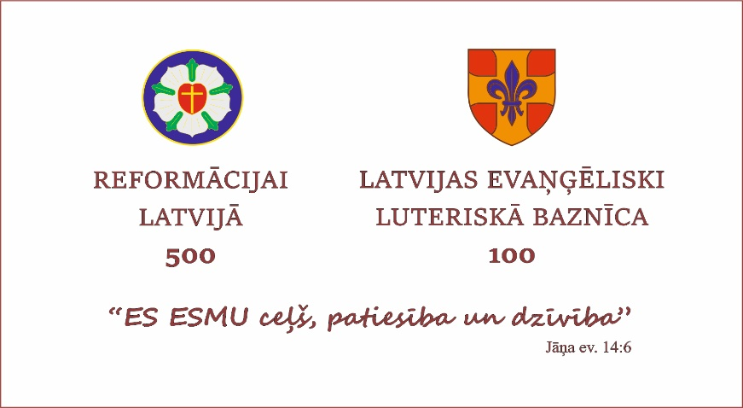
CHURCH DAY
16 July, 2022 Riga

Program

10.00 MORNING PRAYER /Riga St. Peter’s Church/
11.00 MARCH from Riga St. Peter’s Church to the Dom Square
12.00 FELLOWSHIP /Riga St. Mary’s Cathedral yard/
13.00 - VARIOUS EVENTS

Riga St. Peter’s church
- “Reformation Stories”
- Game “In the Footsteps of the Reformation”

Riga St. John’s church
- 14.00-15.30 “Reformation in Stories and Songs” together with pastor Gints and Riga St. John's parish choir

Dom square
- Sunday school for children
- Photo corner
- Praise concert and testimonies
- Giant Games
- Magazine “Sunday Morning”, Christian books and souvenirs

Riga Dome Cathedral yard
- 13.00-21.00 Open café

Riga Dome Cathedral
- 13.00-16.00 Guided tours
- 14:00 Movie “The Secret of the Organ of Dome”
- 15:00 Presentation of the book and meeting the author – bishop emeritus Pavils Bruvers

17.00 WORSHIP SERVICE - ELCL 100-year anniversary,
consecration of bishop electus Rinalds Grants and bishop electus Uldis Gailītis
19.00 FELLOWSHIP, ELCL birthday cake
21.00 CONCERT “I am the way, the truth, and the life”

